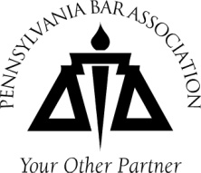
September 18, 2014
Dear Colleague:
Re: Eighth PBA Diversity Summit
The Pennsylvania Bar Association (PBA) Minority Bar Committee is pleased to announce that the Eighth Diversity Summit will be held in Philadelphia on Thursday, October 23, 2014, at the PBI Conference Center, The Wanamaker Building, 100 Penn Square E., Suite 1010 in Philadelphia. You are cordially invited to attend. Simulcast sites have been set up in Mechanicsburg, Stroudsburg and Pittsburgh. Five (5) ethics CLEs will be available.

The theme for this year’s Summit is A Diversity Vision: Strategic Planning to Impact our Communities. The day’s program will begin with a keynote address delivered by Keefe B. Clemons, Esquire, VP & General Counsel, Regulatory Affairs, Northeast Region of Verizon. Mr. Clemons’ remarks will cover the ongoing diversity and inclusion work of Verizon’s legal department. The main program will again be comprised of a series of panel discussions featuring representatives from all sectors of the legal profession on “Attorney Role in Diversifying the Legal Profession,” “The Lawyer Bubble & Barriers Facing Minorities in Smaller Firms,” “Minority Lawyers Practicing Real Estate, Corporate & Commercial Law,” and “How do Legal Practitioners Thrive in Tough Economic Times? Resources, Opportunities and Strategies.” The Summit will also continue the popular panel, “Hot Diversity Issues.” New this year will be a working lunch program featuring PBA President Francis X. O’Connor and PBA President-Elect William H. Pugh, V on the PBA State of Diversity.
The overall purpose of the Diversity Summit is to foster dialogue statewide about diversity and inclusion in all sectors of the legal community, as well as to encourage collaboration and an exchange of best practices among organizations involved in diversity efforts. It also presents wonderful networking opportunities. In keeping with the spirit of encouraging an exchange of ideas, time has been built into the agenda for questions from the audience.
Immediately following the Summit you are encouraged to attend the Hispanic Bar Association of Pennsylvania’s 25th Annual Legal Education Fund Banquet. The Banquet will take place only five blocks from the Summit at the Ballroom at The Ben, 834 Chestnut St., Philadelphia, PA 19107 and runs from 5:00 pm to 7:30 pm. To register and buy tickets for the Banquet, visit: http://www.hbapa.net/lef-info.
Finally, the Asian Pacific American Bar Association of Pennsylvania will be having their 2014 Annual Banquet on Friday, October 24, 2014 at 6:00 pm. Registration materials are available at www.apaba-pa.org. We encourage you to attend this important diversity-related event as well.
Enclosed is a copy of the Agenda and a registration form for the Summit. Please complete and return your registration form as soon as possible, for space is limited. Once we reach capacity, we will no longer accept registrations. Note: We are also giving individuals the opportunity to sponsor the Summit for $100 as “Friends of the Committee.” We hope you will take this opportunity to support this important event in this way.
We look forward to your participation in the Summit and thank you for your support.
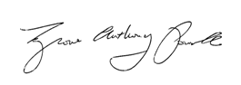
Cordially,
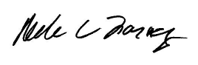

Andrea Farney Tyrone Powell
Co-Chair, Diversity Summit Co-Chair, Diversity Summit

